**Hcl Bank Exercise**

**Question :**

HCL Bank (with serialization/deserialization filename:hclbank.txt - in main method first you will deserialize from hclbank.txt and assign it to ArrayList object "bankList", at the end of main method you should serialize the entire ArrayList object "bankList" and save it in hclbank.txt)

Welcome to HCL Bank Portal!

Enter command(add/balance/quit): test

Sorry, but "test" is not a valid command. Please try again.

Enter command: balance

Account Number:1312

No account exists for this account number.

Enter command: add

Account Number: 123456789

Name: Anbu

Balance ($): 9450

Enter command: add

Account Number: 987654321

Name: Anbu

Balance ($): 1000

Enter command: balance

Account Number:123456789

123456789 Anbu $9,450.00

Enter command: quit

Good bye!

class called "HCLBank"

class called "HCLBankMain" - main class - main method

use ArrayList bankList

Exception Handling

Comment

Naming convention

Method not more than 20 lines...

**Coding Part:**

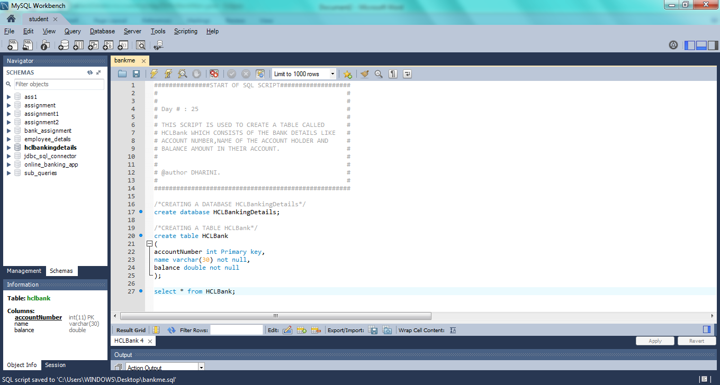

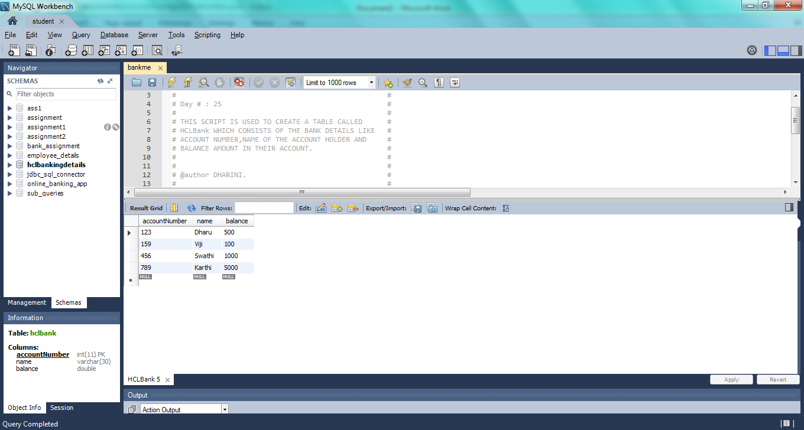

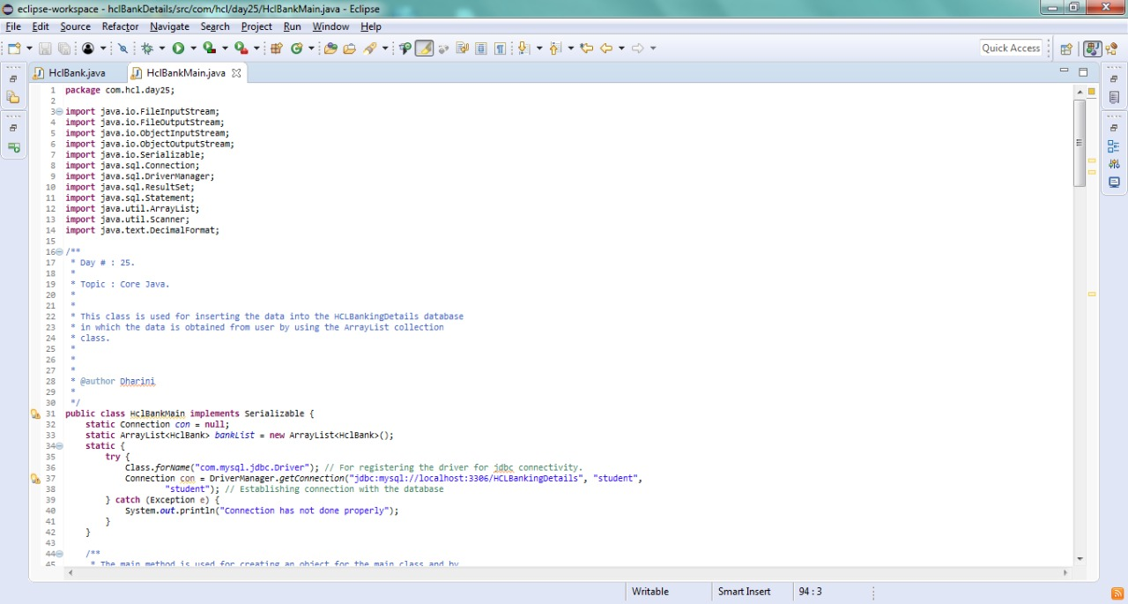

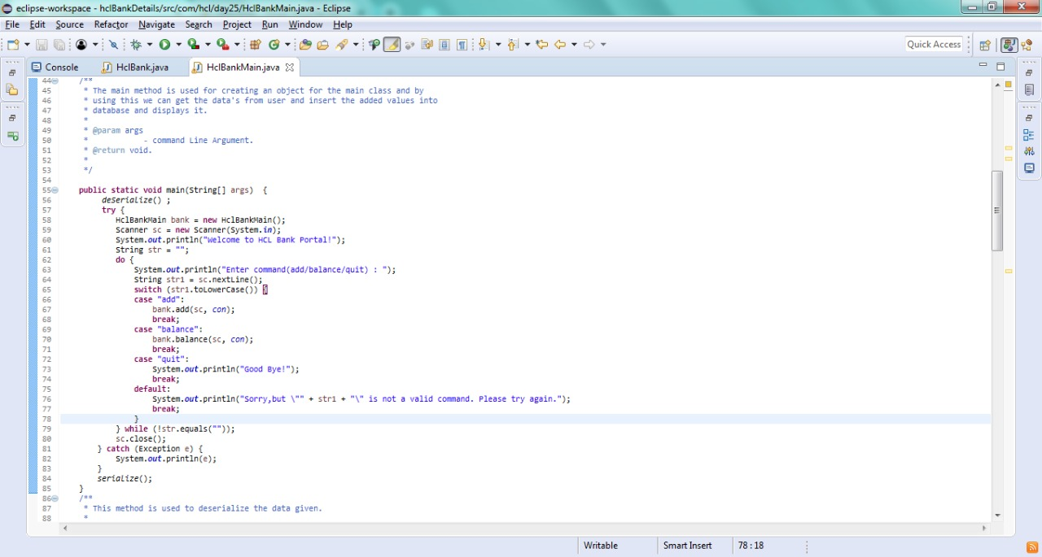

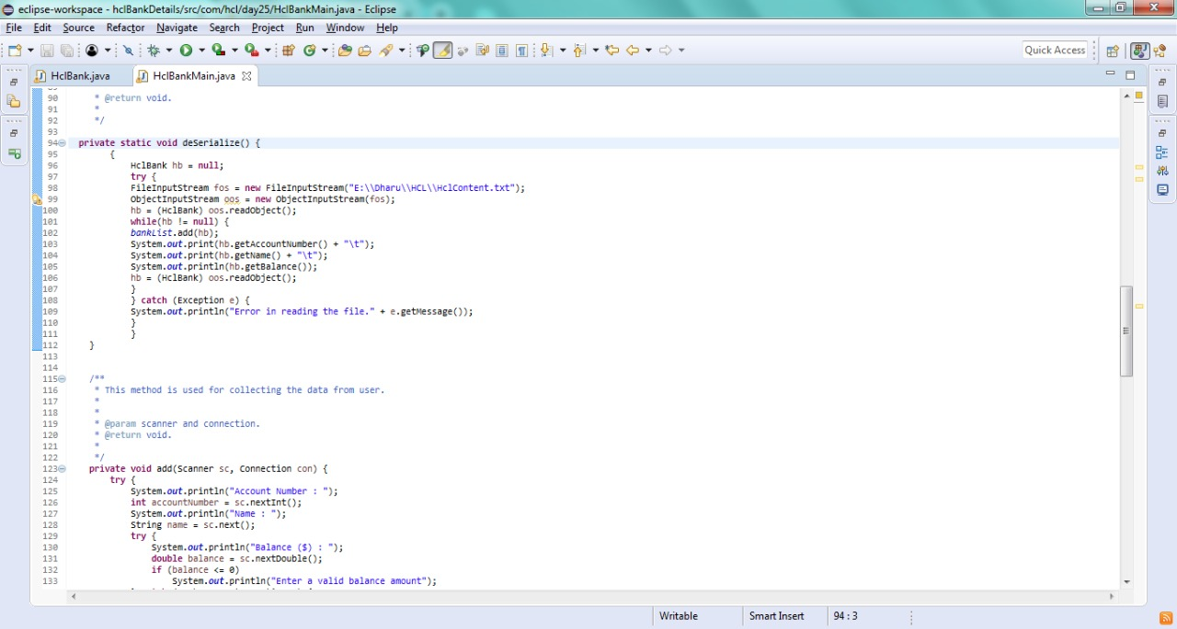

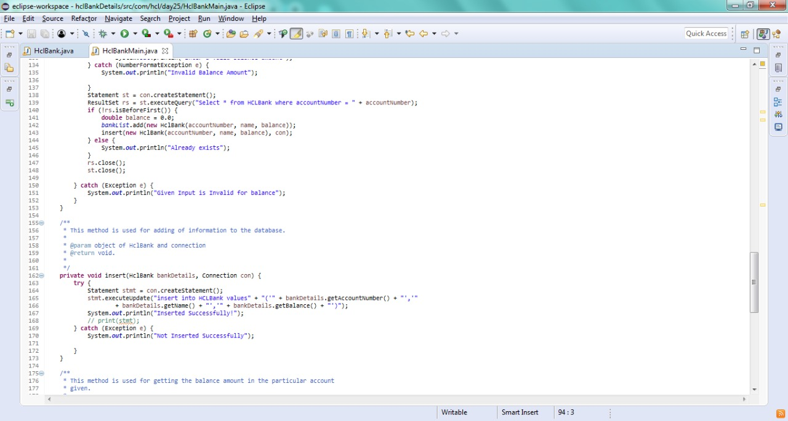

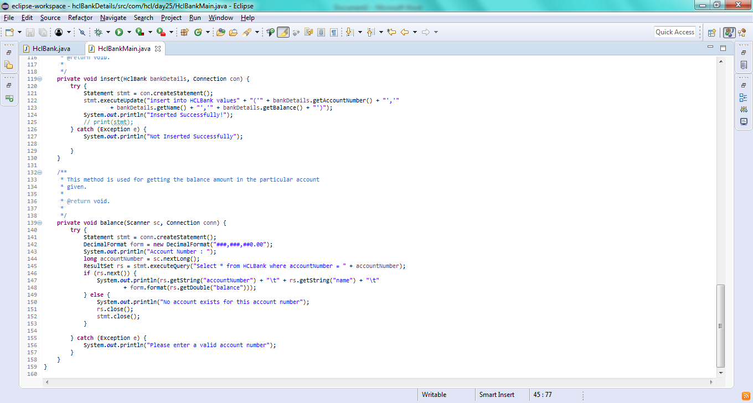

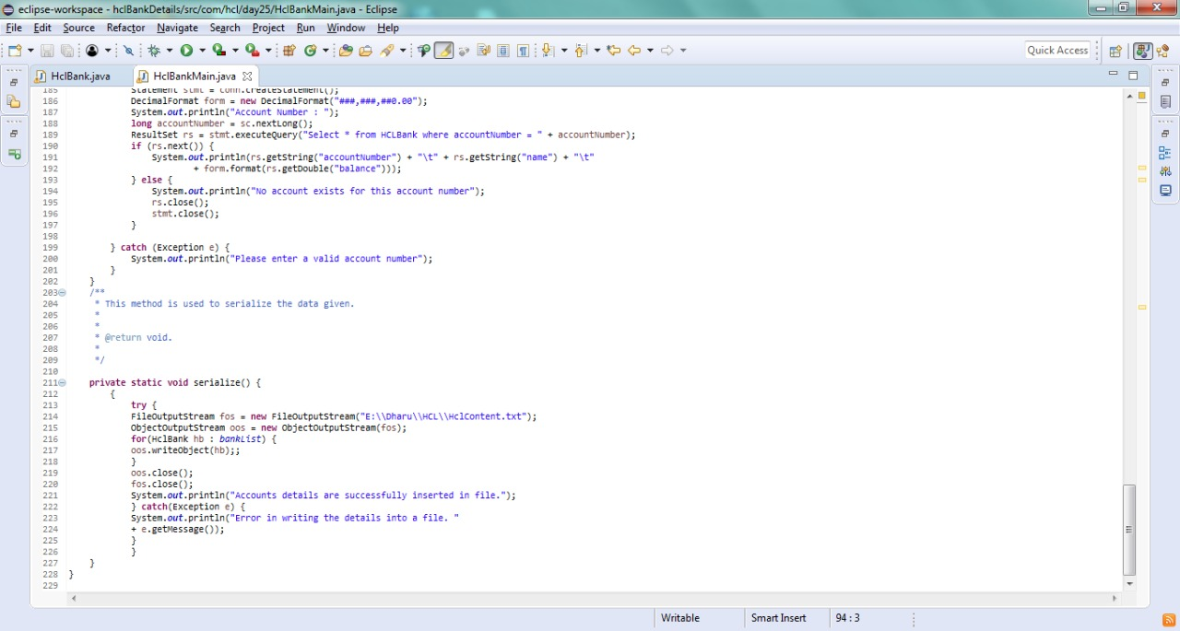

**Output:**

